*Update*: I’ve included another way of saving a separate plot by group in this article. Actually, this is the preferred solution; using dplyr::do() is deprecated.

I’ll be honest: the title is a bit misleading. I will not use purrr that much in this blog post. Actually, I will use one single purrr function, at the very end. I use dplyr much more. However *Make ggplot2 purrr* sounds better than *Make ggplot dplyr* or whatever the verb for dplyr would be.

Basically the idea of this blog post is to show how to create graphs using ggplot2, but by grouping by a factor variable beforehand. To illustrate this idea, let’s use the data from the [Penn World Tables 9.0](http://www.rug.nl/ggdc/productivity/pwt/). The easiest way to get this data is to install the package called pwt9 with:

install.packages("pwt9")

and then load the data with:

data("pwt9.0")

Now, let’s load the needed packages. I am also using ggthemes which makes themeing your ggplots very easy. I’ll be making [Tufte](https://en.wikipedia.org/wiki/Edward_Tufte)-style plots.

library(ggplot2)

library(ggthemes)

library(dplyr)

library(tidyr)

library(purrr)

library(pwt9)

First let’s select a list of countries:

country_list <- c("France", "Germany", "United States of America", "Luxembourg", "Switzerland", "Greece")

small_pwt <- pwt9.0 %>%

filter(country %in% country_list)

Let’s us also order the countries in the data frame as I have written them in country_list:

small_pwt <- small_pwt %>%

mutate(country = factor(country, levels = country_list, ordered = TRUE))

You might be wondering why this is important. At the end of the article, we are going to save the plots to disk. If we do not re-order the countries inside the data frame as in country_list, the name of the files will not correspond to the correct plots!

*Update*: While this can still be interesting to know, especially if you want to order the bars of a barplot made with ggplot2, I included a suggestion by [@expersso](https://twitter.com/expersso/status/846986357792739328) that does not require your data to be ordered!

Now when you want to plot the same variable by countries, say avh (*Average annual hours worked by persons engaged*), the usual way to do this is with one of facet_wrap() or facet_grid():

ggplot(data = small_pwt) + theme_tufte() +

geom_line(aes(y = avh, x = year)) +

facet_wrap(~country)

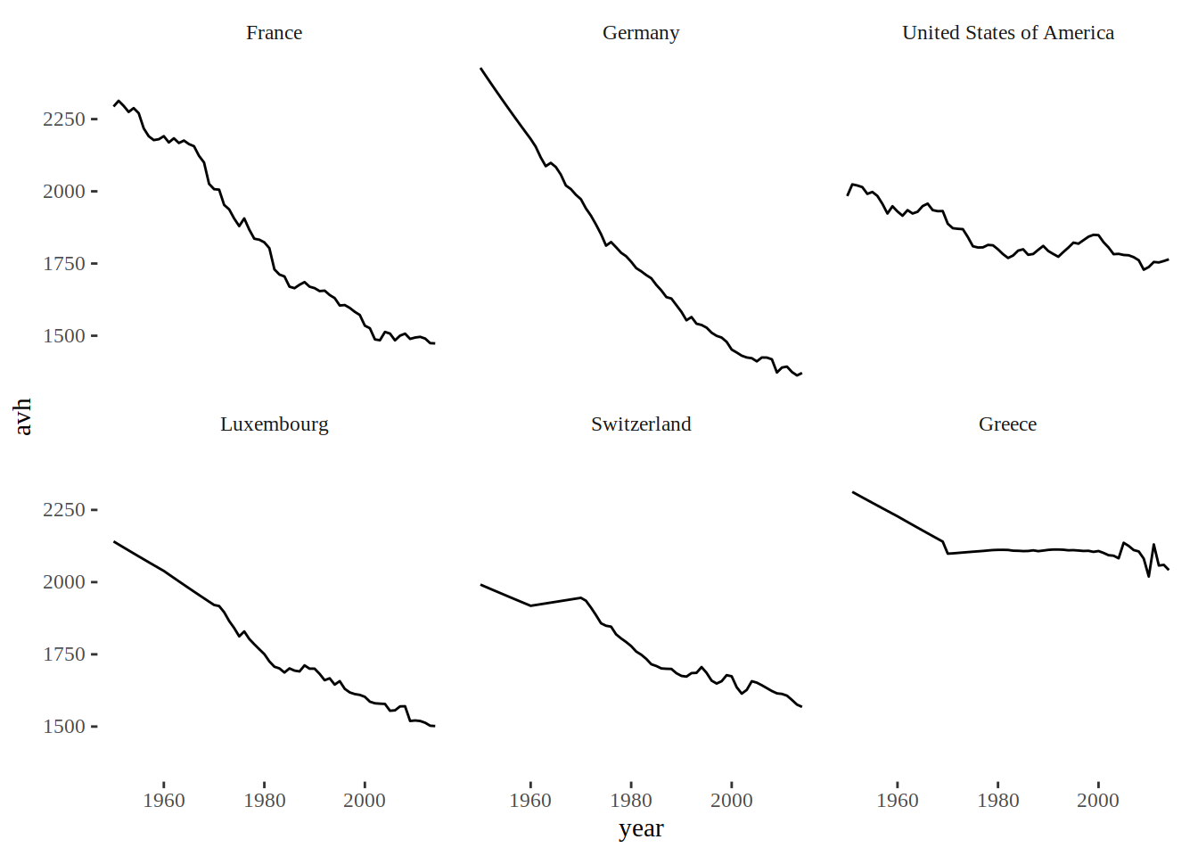

ggplot(data = small_pwt) + theme_tufte() +

geom_line(aes(y = avh, x = year)) +

facet_grid(country~.)

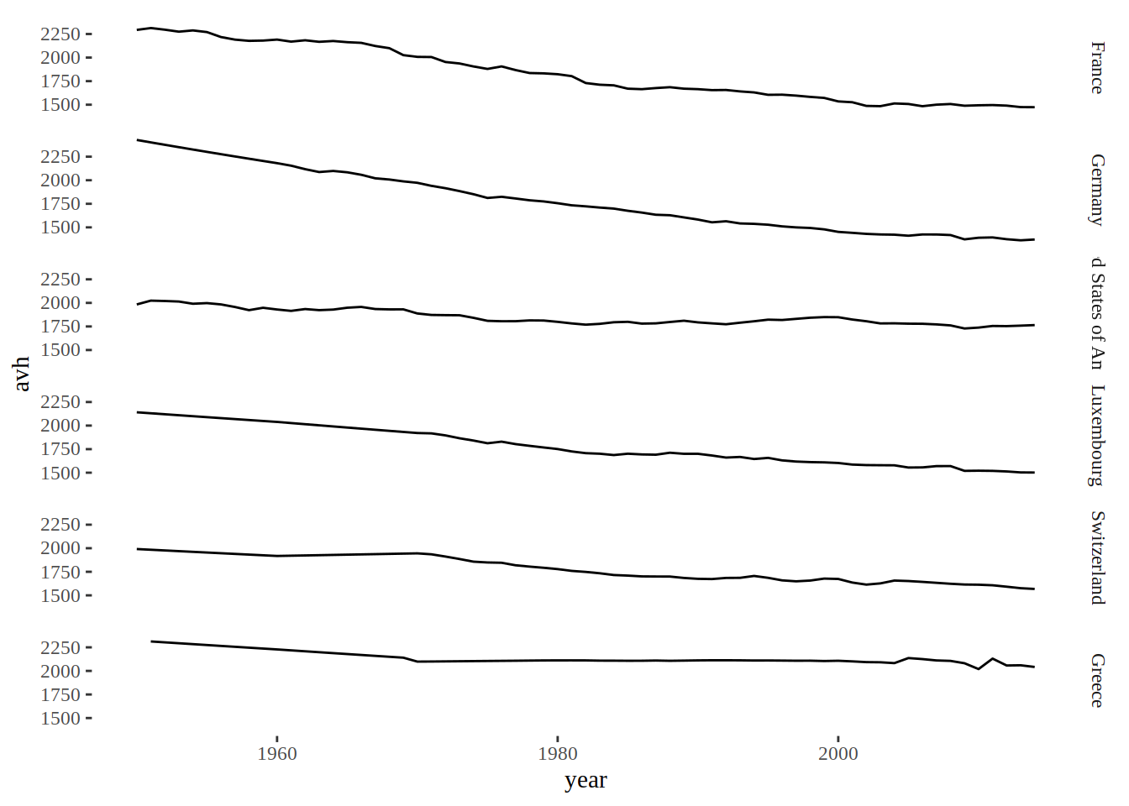

As you can see, for this particular example, facet_grid() is not very useful, but do notice its argument, country~., which is different from facet_wrap()’s argument. This way, I get the graphs stacked horizontally. If I had used facet_grid(~country) the graphs would be side by side and completely unreadable.

Now, let’s go to the meat of this post: what if you would like to have one single graph for each country? You’d probably think of using dplyr::group_by() to form the groups and then the graphs. This is the way to go, but you also have to use dplyr::do(). This is because as far as I understand, ggplot2 is not dplyr-aware, and using an arbitrary function with groups is only possible with dplyr::do().

*Update*: As explained in the intro above, I also added the solution that uses tidyr::nest():

# Ancient, deprecated way of doing this

plots <- small_pwt %>%

group_by(country) %>%

do(plot = ggplot(data = .) + theme_tufte() +

geom_line(aes(y = avh, x = year)) +

ggtitle(unique(.$country)) +

ylab("Year") +

xlab("Average annual hours worked by persons engaged"))

And this is the approach that uses tidyr::nest():

# Preferred approach

plots <- small_pwt %>%

group_by(country) %>%

nest() %>%

mutate(plot = map2(data, country, ~ggplot(data = .x) + theme_tufte() +

geom_line(aes(y = avh, x = year)) +

ggtitle(.y) +

ylab("Year") +

xlab("Average annual hours worked by persons engaged")))

If you know dplyr at least a little bit, the above lines should be easy for you to understand. But notice how we get the title of the graphs, with ggtitle(unique(.$country)), which was actually the point of the stackoverflow question.

*Update:* The modern version uses tidyr::nest(). Its documentation tells us:

*There are many possible ways one could choose to nest columns inside a data frame. nest() creates a list of data frames containing all the nested variables: this seems to be the most useful form in practice.* Let’s take a closer look at what it does exactly:

small_pwt %>%

group_by(country) %>%

nest() %>%

head()

## # A tibble: 6 x 2

## country data

## <ord> <list>

## 1 Switzerland <tibble [65 × 46]>

## 2 Germany <tibble [65 × 46]>

## 3 France <tibble [65 × 46]>

## 4 Greece <tibble [65 × 46]>

## 5 Luxembourg <tibble [65 × 46]>

## 6 United States of America <tibble [65 × 46]>

This is why I love lists in R; we get a tibble where each element of the column data is itself a tibble. We can now apply any function that we know works on lists.

What might be surprising though, is the object that is created by this code. Let’s take a look at plots:

print(plots)

## # A tibble: 6 x 3

## country data plot

## <ord> <list> <list>

## 1 Switzerland <tibble [65 × 46]> <S3: gg>

## 2 Germany <tibble [65 × 46]> <S3: gg>

## 3 France <tibble [65 × 46]> <S3: gg>

## 4 Greece <tibble [65 × 46]> <S3: gg>

## 5 Luxembourg <tibble [65 × 46]> <S3: gg>

## 6 United States of America <tibble [65 × 46]> <S3: gg>

As dplyr::do()’s documentation tells us, the return values get stored inside a list. And this is exactly what we get back; a list of plots! Lists are a very flexible and useful class, and you cannot spell *list* without purrr (at least not when you’re a neRd).

Here are the final lines that use purrr::map2() to save all these plots at once inside your working directory:

*Update*: I have changed the code below which does not require your data frame to be ordered according to the variable country_list.

# file_names <- paste0(country_list, ".pdf")

map2(paste0(plots$country, ".pdf"), plots$plot, ggsave)

As I said before, if you do not re-order the countries inside the data frame, the names of the files and the plots will not match. Try running all the code without re-ordering, you’ll see!

I hope you found this post useful.